ZERO ERROR OF VERNIER CALIPERS
UNDERSTANDING THE ZERO ERROR OF A VERNIER CALIPERS
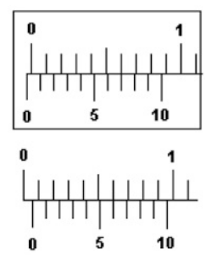
Closed calipers
Measurement
If the vernier scale is left of the main scale, then we have negative zero error.
Check where both vernier scale and main scale aligns, then Count from the back (from 10), to determine your zero error value.
1.

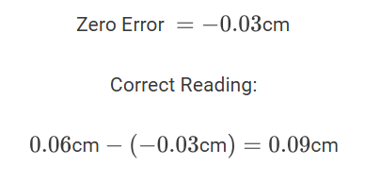

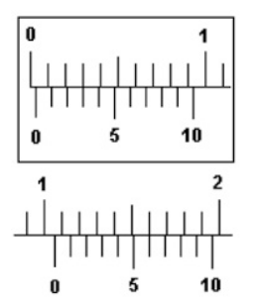
Closed calipers
Measurement
If the vernier scale is right of the main scale, then we have positive zero error.
Check where both vernier scale and main scale aligns, then Count from the front (from 0), to determine your zero error value.
2.

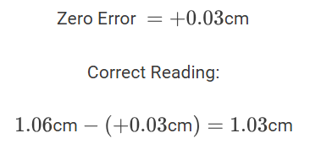

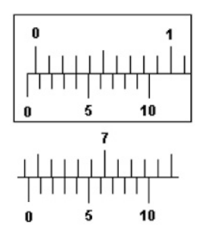
3.
Closed calipers
Measurement

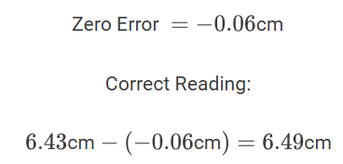

Practice On Reading A Vernier Caliper With Zero Error | Mini Physics - Free Physics Notes

